

COMPILER DESIGN Project

FUZZY STATEMENTS

TO

NATURAL LANGUAGE CONVERTER

b-10

Submitted by:

Sakshi Dubey(13103716)

Anand Kumar Tiwari(13103445)

Rohit Singh (13103736)

**ABSTRACT**

The aim of this project is to develop an efficient tool which takes a set of fuzzy statements, processes them intelligently and then generates an output in the form of a complete natural language statement.

The fuzzy statement will specify the membership value of a subject in a particular set. This membership value defines as to what degree is the particular quality (set) is possessed by that subject. A subject may be associated with more than one set. We will process the membership values of all the sets and generate a complete statement in natural language.

**Project Salient Features:**

* Lexical analysis
* Syntactic analysis
* Semantic analysis
* Intermediate Code Generation
* Code Optimization
* Natural Language Processing

**INTRODUCTION**

In recent years, the research and study of fuzzy logic has increased significantly and therefore a huge number and a variety of applications based on fuzzy logic have come into existence. One such widely known application is natural language processing and analysis. It is commonly recognized that many phenomena in natural language lend themselves to descriptions by fuzzy mathematics, including fuzzy sets, fuzzy relations and fuzzy logic.

However, not much research and study has been done on the subject of processing of fuzzy logic (fuzzy sets and relations) and generating natural language as the output (retranslation).In this project we undertake this research and hence process a given set of fuzzy statements and convert it to natural language.

**BACKGROUND STUDY**

**Fuzzy Logic:**

Fuzzy logic is a form of many-valued logic; it deals with reasoning that is approximate rather than fixed and exact. Fuzzy logic variables may have a truth value that ranges in degree between 0 and 1. Fuzzy set theory defines set membership as possibility distribution. The membership of elements in a set are described with the aid of membership functions.

The membership function of a fuzzy set is a generalization of the indicator function in classical sets. In fuzzy logic, it represents the degree of truth as an extension of valuation. It is a function from a universal set U to the interval [0, 1]. A fuzzy set is a pair (U, m) where U is a set and m: U [0, 1]. Some of the popular applications of fuzzy logic in the real world are recognition of handwriting, objects, voice; simplified control of robots, cruise-control for automobiles, single button control for washing-machines, improved fuel-consumption for automobiles, etc.

**Natural Language:**

Natural Language enables communication between people and computers and automatic translation to enable people to interact easily with others around the world. It is any language which arises in an unpremeditated fashion as the result of the innate facility for language possessed by the human intellect.

**Natural Language Processing (NLP):**

Natural Language Processing is a field of computer science which tells us about the interaction between human and computer languages. Technically, NLP is the process of a computer extracting meaningful information from natural language input and/or producing natural language output.

***Some of the applications of NLP are:***

* Automatic summarization
* Machine translation
* Optical character recognition (OCR)
* Parsing •
* Speech recognition

**Retranslation:**

In dealing with natural language, there are three main types of procedures:

a) Procedures that convert natural language into fuzzy propositions;

b) Procedures that manipulate these fuzzy propositions through approximate reasoning and yield other fuzzy sets;

c) Procedures that convert these given fuzzy sets again into statements in natural language.

This last type of procedure is known as linguistic approximation of the second kind or Retranslation. In other words, the procedure of retranslation is the problem of converting fuzzy propositions obtained by approximate reasoning to statements in natural language. This procedure has been little researched.

**Requirement Analysis:**

**Software:**

* Operating Environment : any operating system from the following
  + Microsoft Windows XP Professional SP3/Vista SP1/Windows 7 Professional
  + Ubuntu 9.10
  + Solaris OS
  + Macintosh OS X 10.6
* Design and Development Platform :
  + Java Platform Standard Edition (Java SE 6)

**Hardware:**

* 800MHz Intel Pentium III or any equal or better processor
* 1GB Memory

**Functional Requirements:**

* The format of a fuzzy membership function is:

m (a) (b) = 0.4 ;

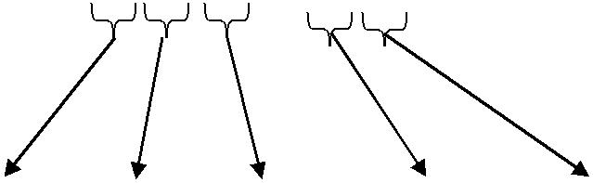

|  |  |  |  |  |
| --- | --- | --- | --- | --- |
| keyword to |  | value | delimiter |  |
| specify | SET | SUBJECT |  |  |
| membership |  |  |
|  |  |  |  |
| function | name | name |  |  |
|  |  |  |  |

* The program would intelligently process the fuzzy sets taken as the input from the user and give meaningful natural language statement(s) as the output.
* The format of a fuzzy membership function is:

m (a) (b) = 0.4 ;

**Non-functional Requirements:**

* The program requires a computer system with all the necessary above mentioned software and hardware platforms installed for smooth operation of the program.

**User Requirements:**

The program allows the user to enter the information in the form of fuzzy membership functions in the above specified format.

After the user has given the input to the program, it should process the input and the user should receive the output in the form of natural language statements.

**Flowchart:**

**Detailed Design:**

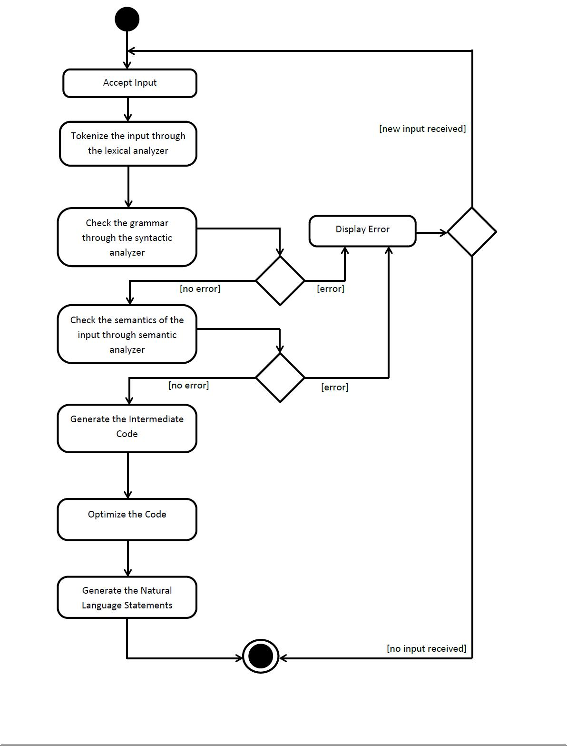

**IMPLEMENTATION**

**Regular Expressions:**

regexStatement = m+ob+name+cb+ob+name+cb+eq+val;

regexCondition = m+ob+name+cb+ob+name+cb+rel+val;

normalInput = regexStatement + d;

elseSyntax = e + "((" + regexStatement + ")*)";

elseIfSyntax = elif+ob+ regexCondition + cb+ "((" + regexStatement + ")*)";

ifSyntax = i+ob + regexCondition + cb+ "((" + regexStatement + ")*)";

iteSyntax = ifSyntax + "((" + elseIfSyntax + ")*)" + "((" + elseSyntax + ")?)";

ite = "(" + iteSyntax + d + ")" + "(((" + normalInput + ")" + "|" + "(" + iteSyntax + d + "))*)";

String start = "(((" + normalInput + ")+)" + "((" + ite + ")*))" + "|" + "((" + ite + ")+)";

**Keys:**

m = m Keyword

ob = Open Bracket

name = Name cb = close bracket

eq = assignment operator

val = value

rel = relational operator

i = if keyword

elif = else if keyword

e = else keyword

d = delimiter

**TESTING REPORTS**

The user interface shows an input field, an output field and a ‘Convert’ button.

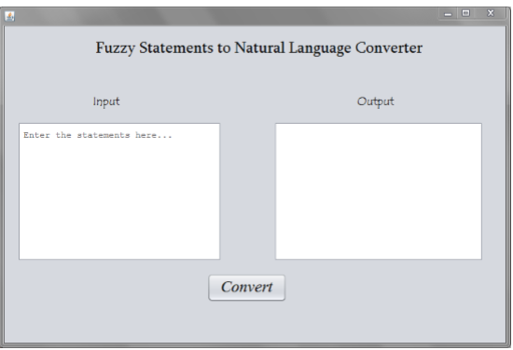

* The program would intelligently process the fuzzy sets taken as the input from the user and give meaningful natural language statement(s) as the output.

The user interface shows an input field, an output field and a ‘Convert’ button.

The input’s format is:

“m(set)(subject)=m.v”

or,

“if(m(set1)(subject1)relop(m.v)) m(set2)(subject2)=m.v”,

where m.v & relop are the membership value of the subject in the particular set and a relational operator, respectively.

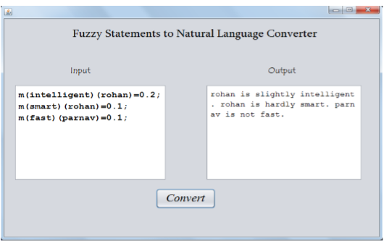

The input is validated using the regular expression. The values of the subject and corresponding set are stored in a table. If the input entered is not according to the regular expression specified, then an error is thrown at the corresponding line number. A statement has to end with a ‘;’. Multiple statements are allowed in a single line, given that each statement is separated using a ‘;’.

**1.** **Correct case 1:**

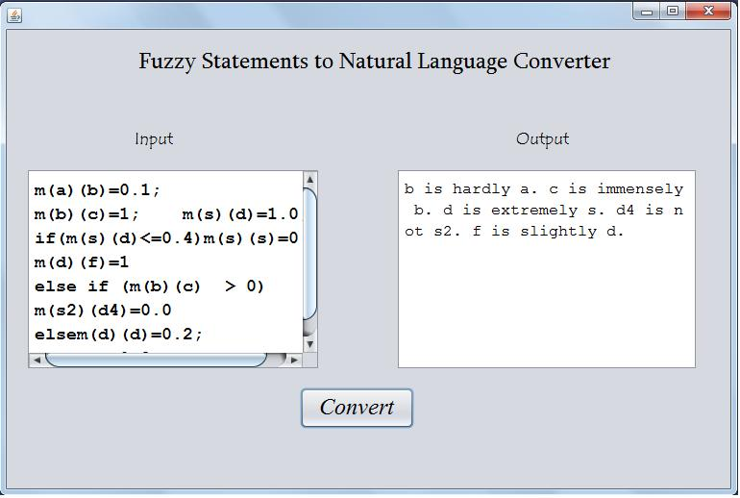

**2. Correct case 2:**

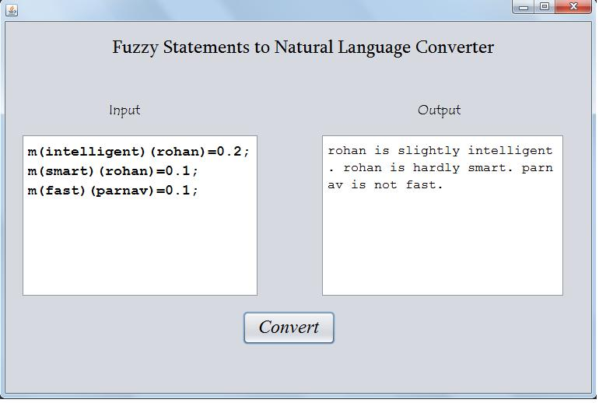

Semantic Error Case

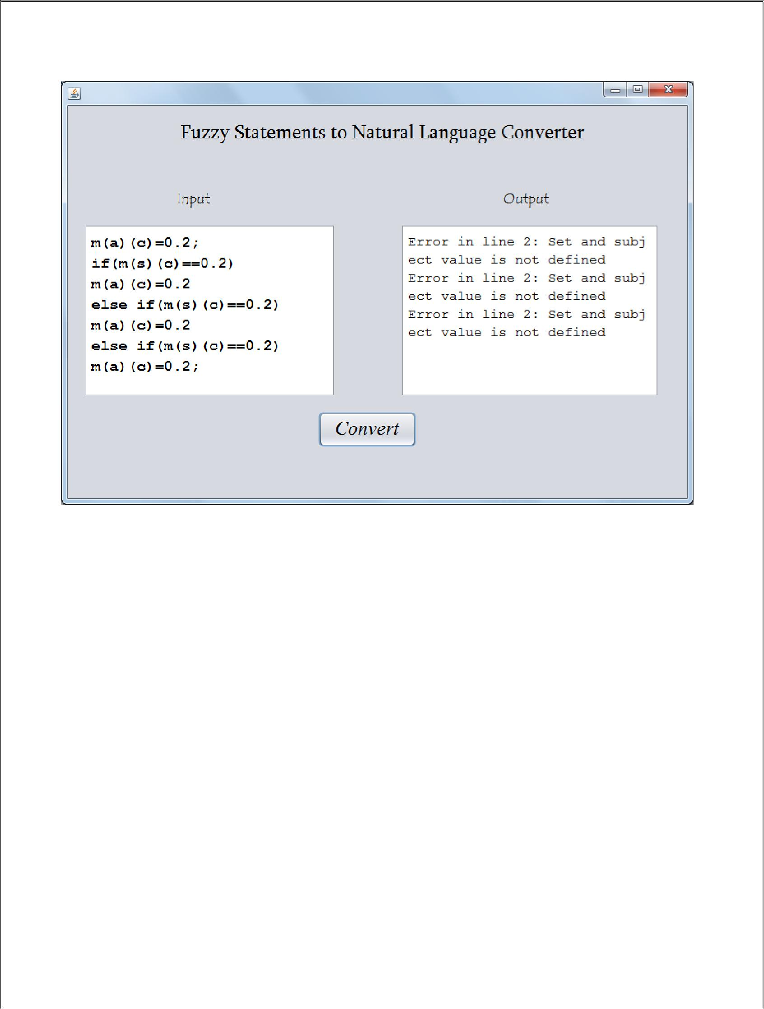

**Future Scope:**

From the area of Machine Learning, algorithms like Supervised/unsupervised algorithms can be implemented for better identification and grouping of subjects.

After applying Machine Learning Algorithms; improved, optimized and general Natural Language statements can be generated.

Currently, only simple fuzzy values in the range 0 to 1 are being considered by the program. In the future, interval values of fuzzy sets can also be incorporated in the program.